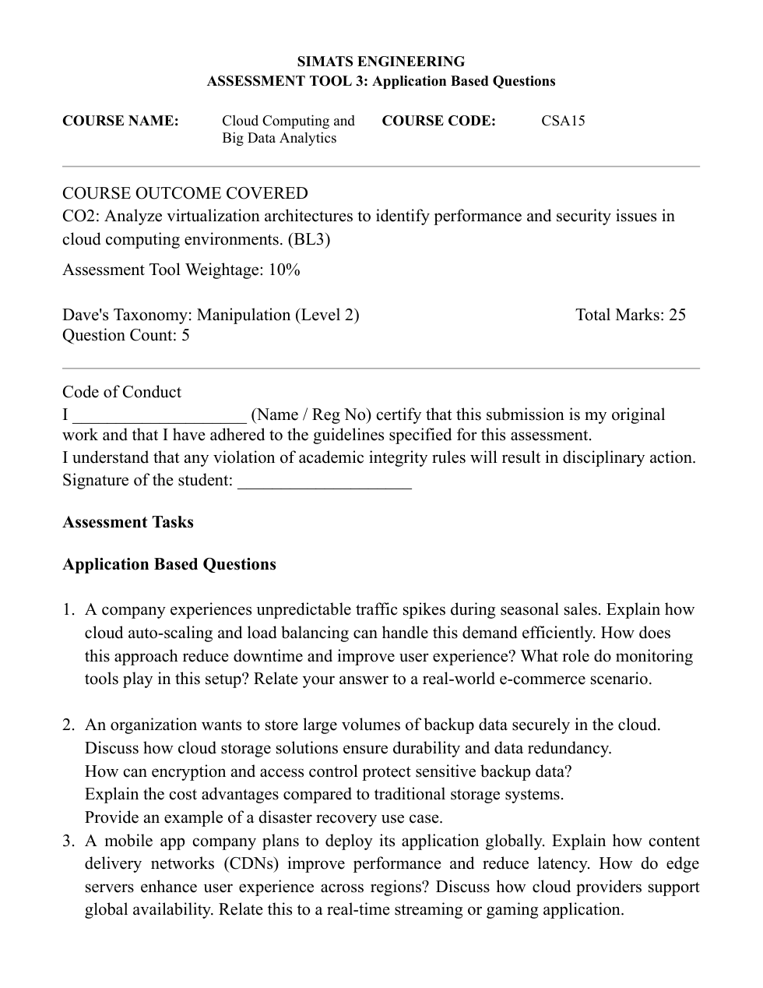

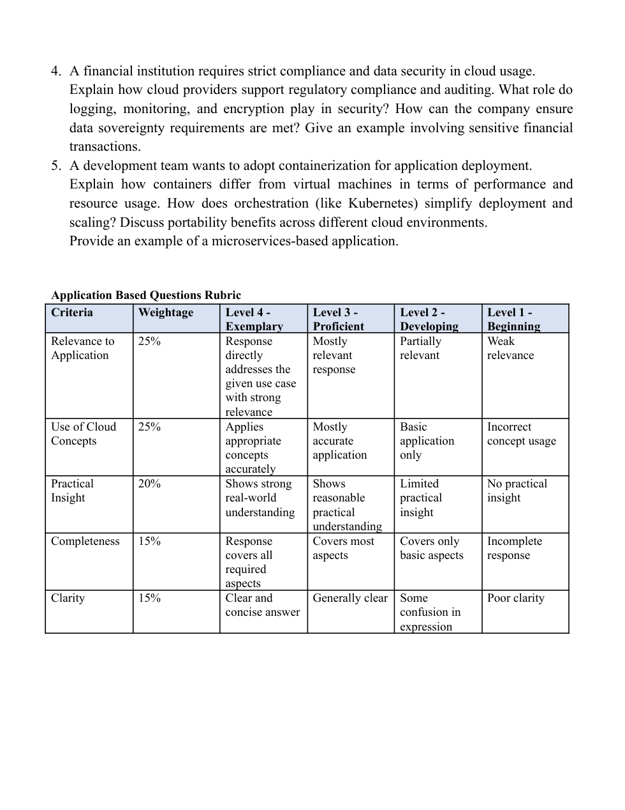

1. Cloud Auto-Scaling and Load Balancing
• Auto-scaling: Automatically adds or removes cloud servers according to traffic and resource usage. During seasonal sales, extra servers are added when the number of customers increases and removed when demand falls.
• Load balancing: Distributes incoming customer requests across several servers so that one server does not become overloaded. If a server fails, traffic can be sent to healthy servers.
• Downtime and user experience: Together, these methods help keep the website available, reduce slow page loading and prevent failed purchases during peak demand.
• Monitoring tools: Tools monitor CPU usage, memory, request rate, response time and errors. Alerts and scaling rules help the system react before performance becomes poor.
• Real-world example: During a large online shopping sale, an e-commerce website can automatically start more application instances and use a load balancer to spread product searches and checkout requests across them. After the sale, unused instances are removed to save cost.
Result: The website handles sudden traffic efficiently, stays responsive and pays for extra capacity only when needed.

2. Secure and Cost-Effective Cloud Backup Storage
• Durability and redundancy: Cloud storage keeps multiple copies of data across separate disks or locations. If a disk or facility fails, another copy can be used. Versioning can also help recover earlier versions of files.
• Encryption: Encryption protects data at rest and during transfer. Only authorized systems or users with the correct keys can read the protected data.
• Access control: Identity and access management, strong authentication and least-privilege permissions restrict backups to approved staff and services. Access logs help identify suspicious activity.
• Cost advantages: Organizations can avoid buying and maintaining large storage devices, paying for electricity, cooling and physical space. Cloud storage can scale as needed and often offers lower-cost archive tiers for rarely accessed backups.
• Disaster recovery example: If a company’s office server is damaged by a fire, it can retrieve encrypted backups from cloud storage and restore its database and files on replacement servers or in another region.
Result: Redundant copies, encryption and controlled access improve recovery and protect sensitive backup data.

3. CDNs, Edge Servers and Global Application Performance
• Content Delivery Network (CDN): A CDN stores cached copies of content, such as images, video segments and software files, at locations close to users. Requests can be served from a nearby location instead of travelling to the main server.
• Reduced latency: Shorter network distance and fewer long-distance requests reduce delay, improve loading speed and reduce traffic reaching the origin server.
• Edge servers: Edge servers process or deliver content near users. They can support faster responses for live video, game assets and other time-sensitive services.
• Global availability: Cloud providers offer regions and availability zones in different geographic areas. Applications can deploy in multiple regions, use traffic routing and replicate data to reduce dependence on a single location.
• Example: A global video-streaming app can cache popular video segments at CDN edge locations. Viewers in different countries receive content from nearby servers, reducing buffering. For online gaming, nearby edge infrastructure can reduce delay for game updates and selected real-time services.
Result: Users in different regions receive content faster, with less buffering and better availability.

4. Cloud Compliance, Auditing and Financial Data Security
• Regulatory compliance: Cloud providers offer security and compliance controls, documentation and certifications that can help an institution meet applicable requirements. The institution must still configure services correctly and meet its own legal obligations.
• Logging and monitoring: Logs record sign-ins, data access, configuration changes and administrative actions. Monitoring and alerts can identify unusual access, repeated failed logins or suspicious transactions. Audit reports help investigators review events.
• Encryption: Encryption protects sensitive financial information while stored and while moving across networks. Strong key management and restricted key access add protection.
• Data sovereignty: The institution should select approved cloud regions, check where backups and replicas are stored, review provider contracts and configure services so data remains in permitted jurisdictions. Cross-region transfers must follow applicable rules.
• Example: For online banking transfers, access should be limited by role, sensitive data should be encrypted, transaction and administrator actions should be logged, and alerts should flag unusual activity. Auditors can review records to verify that required controls were followed.
Result: Proper configuration, monitoring, encryption and regional controls help protect transactions and support audits.

5. Containers, Virtual Machines and Kubernetes
• Containers versus virtual machines: A virtual machine runs a full guest operating system on virtualized hardware. A container packages an application and its dependencies but shares the host operating-system kernel. Containers are usually lighter and start faster, while VMs provide a separate guest OS boundary.
• Performance and resource usage: Because containers have less overhead, more application instances may run on the same host. Both containers and VMs still need resource limits and security controls.
• Orchestration with Kubernetes: Kubernetes schedules containers across machines, restarts failed containers, supports service discovery and rolling updates, and can scale application replicas according to demand.
• Portability: A container image can run consistently on compatible developer machines, private clouds and public clouds, reducing differences between environments. Platform-specific storage, networking and identity settings may still need configuration.
• Microservices example: An online shopping system may run separate containers for the product catalogue, user accounts, payments and orders. Kubernetes can scale the catalogue service during high traffic and restart a failed payment-service container.
Result: Containers make deployment lightweight and portable, while Kubernetes automates management and scaling.

